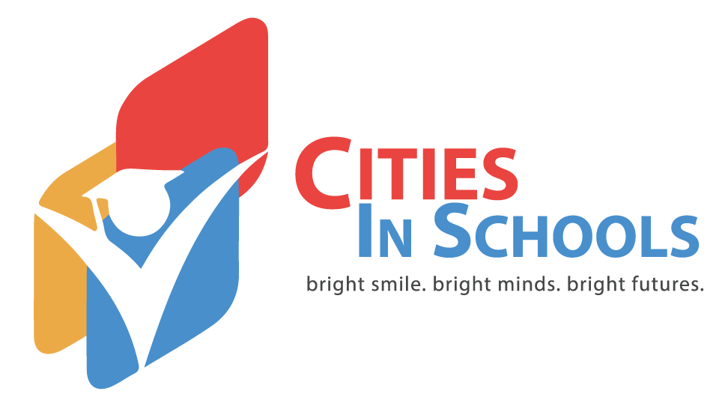**PRESS RELEASE**

April 11, 2018

FOR IMMEDIATE RELEASE

A NEED FOR THE RISE OF AFTERSCHOOL PROGRAMS

Ardmore, Okla.

Cities In Schools is proud to announce its growing success. Afterschool programs are a very important part of a community because they help children learn, save taxpayers money and pushes families to join in the educational process. Unlike daycares or other programs, Cities in Schools focuses on the educational aspect.

Over the summer months, Cities In Schools hosts a summer camp that keeps children fed with healthy meals and snacks, engaged with interactive projects and encourages families to participate where possible. Currently, the summer camp enrollment is at 83% of capacity and this is an improvement over that last year’s open-enrollment numbers. 4th and 5th grade openings are still available.

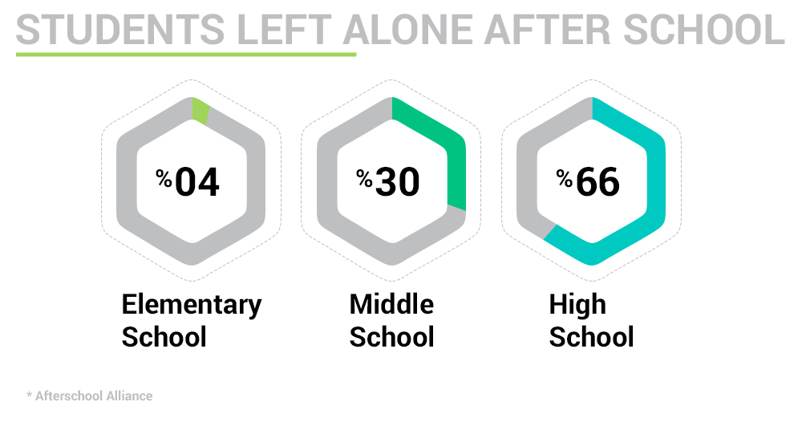

The Afterschool Alliance ([afterschoolalliance.org](http://afterschoolalliance.org/)) has determined that about 11.3 million children in our country are left unsupervised from 3pm to 6pm. 34% of these children are in elementary and middle schools. This rate can increase the potential for kids to commit crimes, use drugs or become a teen parent.

Sara Orellana, Director of Cities in Schools stated, “The goal of CIS is to be the bridge between the community and families, helping families navigate the early and formative years of school. I truly believe that literacy is the great equalizer, allowing children to pursue their dreams and have a bright future.“

Programs like Cities In Schools help the bottom line for states and taxpayers by lowering the potential for crime, welfare costs and can increase a child's performance in school. For every dollar spent on an afterschool program, nine dollars is saved. These programs also increase a child’s earning potential. Cities In Schools is a gateway for our community to make big changes in the world.

For these programs to operate the support of the community is needed. Contributions, tuition, and sponsorship through events such as the upcoming Corporate Fitness Challenge ([ardmorecorporatebusinesschallenge.com](http://ardmorecorporatebusinesschallenge.com/)) that begins May 26, 2018 all help maintain Cities In Schools.

Cities In Schools asks the community to enroll their children in Summer Camp and Afterschool programs ([citiesinschoolsardmore.org/registration](http://citiesinschoolsardmore.org/registration)) so the children of our community can flourish through education and fun.

Cities In Schools is a non-profit educational organization located in Ardmore, Oklahoma. Catering to children in elementary and middle school, Cities In School provides nutritious snacks and meals to all students in the program as well as one-on-one time that children need to succeed. Learning through fun is essential through the program.

Cities In Schools

Sara Orellana

Director

(580) 223-8762

Media Contact

Shawn Terry

IOP Marketing

(580) 618-5510