Hello!

As you are aware, there are some fascinating changes happening in Oklahoma that could finally change the course of our state and the positions we hold in the country.  Many House and Senate seats are **available for election** and **we need your support!**

*Senate District 24* is going to be difficult with the Republican opposition that has been out ahead, running since early 2017.  Rest assured though, that **we will put up a fight**.  Oklahoma has had **enough of the status quo** and I am getting to the doors to take back the district.

I am a *wife*, a *mother*, and a *teacher of 14 years* who has supported education all my life.  During the Teacher Walkout, I remained at the capitol every day, speaking with representatives and senators from all over the state urging them to consider valiant funding efforts of our education system.

With your help, we can turn the tide in Oklahoma. Together, we can finally put our great state on a path to focus on our **children's future**.

Can we count on your support?

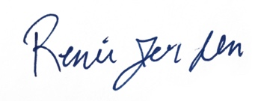

**Renée Jerden**

State Senate District 24 Candidate for All of Us